USER MANUAL PROCEDURE
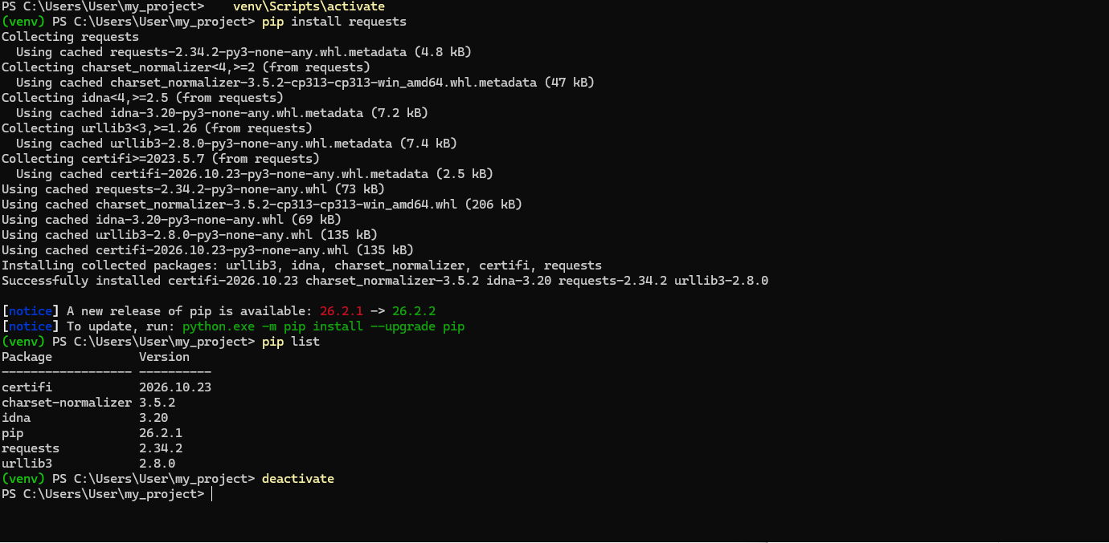

API Reference Entry

Endpoint to document
Create a new task in a project management app (authenticated user).

Sections to write, in this order
1. Title and endpoint
Method and path, for example POST /api/v1/projects/{projectId}/tasks
2. Description (2 to 3 sentences)
What the endpoint does, who can call it, and what it returns.
3. Headers table
Header | Required | Value | Description
Authorization | Yes | Bearer <token>
Content-Type | Yes | application/json
4. Path parameters table (name, type, required, description)
- projectId: string, required
5. Query parameters
Write “None” if you have none.
6. Request body table (name, type, required, description)
Fields you must include:
- title: string, required, give a length limit
- description: string, optional
- assigneeId: string (user ID)
- dueDate: string, ISO 8601 format (YYYY-MM-DD)
- priority: string, one of low, medium, high
7. Example request
Valid JSON using realistic values.
8. Example successful response (201)
Valid JSON that repeats your request fields and adds server-generated fields such as id, status, createdAt.
9. Response codes table (code, name, when it happens)
Code | Meaning to explain
201 | Task created
400 | Malformed JSON or wrong Content-Type
401 | Missing or invalid token
403 | Valid token, but no permission in this project
404 | Project or assignee not found
422 | Valid JSON, but a field fails validation
429 | Rate limit exceeded
500 | Server error

